|  |
| --- |
|  |
| MOTORIDE |
| Project Documentation of DISM (Semester II) |

**our team members**

* MARIAM ABDUL WAHID Student1059491
* SHAIKH TAHA ALEEM Student1074265

**Faculty** = Miss Aatika Liaquat

**Batch Code** = 1803B2

**Curriculum**= 6673

**Semester**= HDSE-2



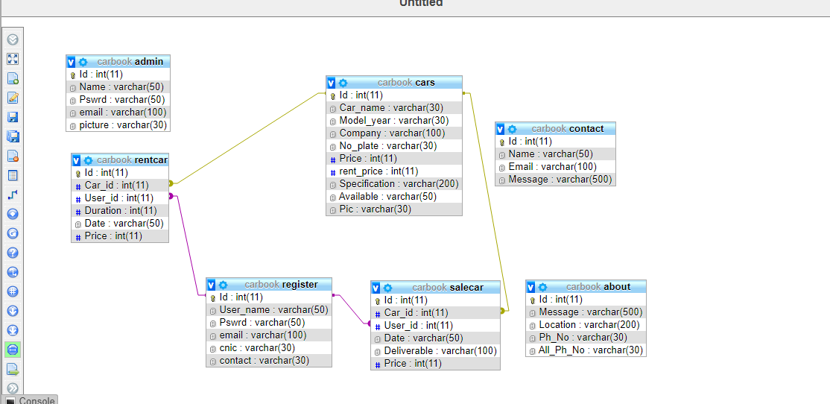

Login Page: -

This is the entry point of our application. First of all, you’ll see this page then you can select your role from combo box and if your id password matches with the id password in our data base you can see the nest page.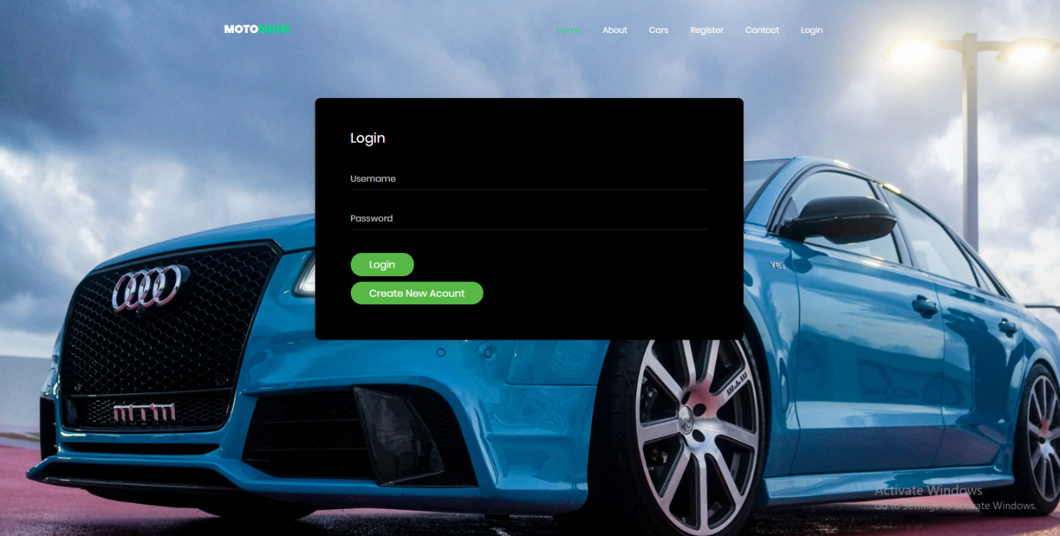

Code Snippet

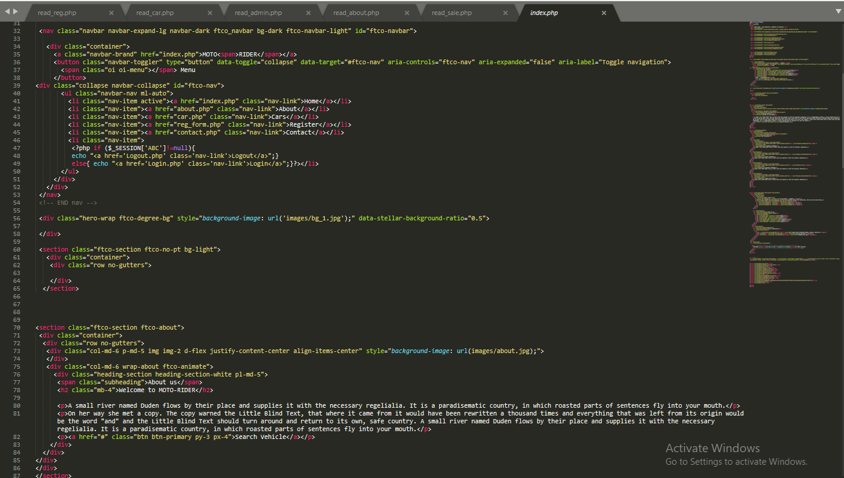



HOME:-

This is the page where purchases are made in our bookshop are to be added in database.

From here you can add update or delete any purchase you made. As well as you can search for the purchases.



Code Snippet 

AHA

ABOUT: -

This page determines the sales in our MOTORIDE. That can be added, updated deleted or searched as per the requirements.

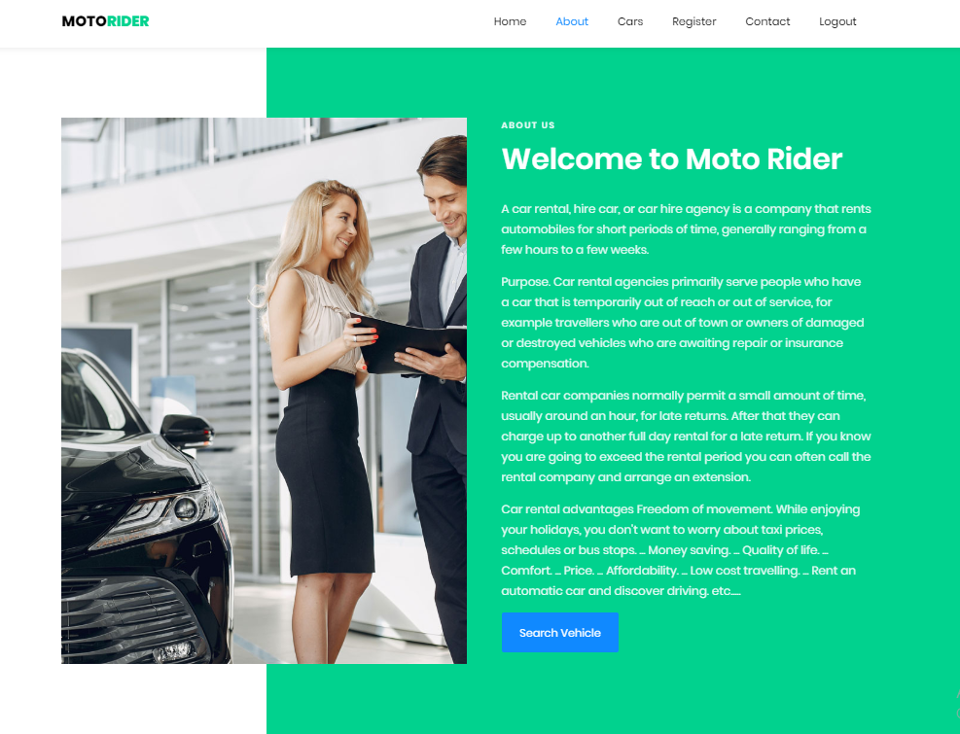

Code Snippet

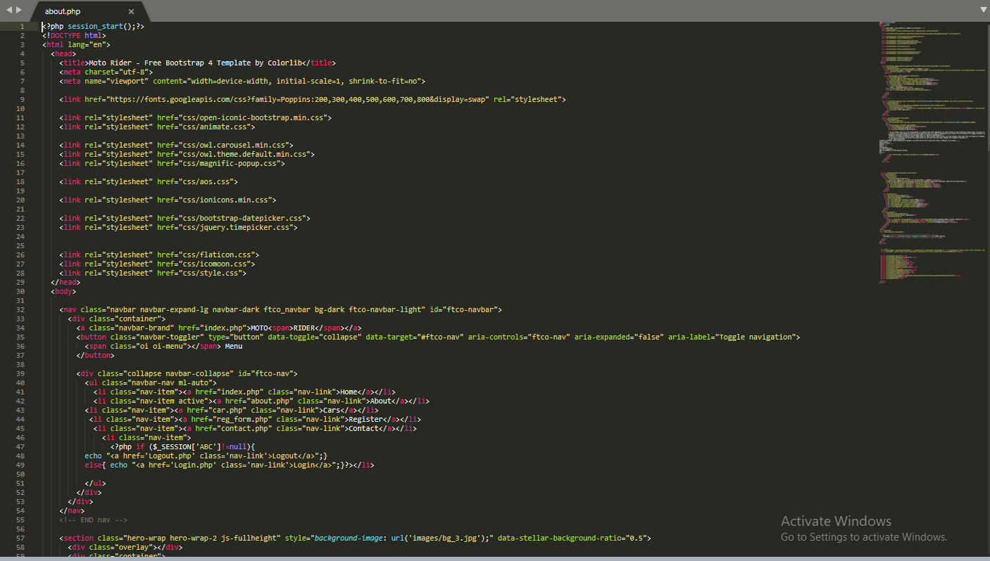



## 

CARS: -

Here a user can view all the stock in our MOTORIDE, he or she can search for a particular book using it’s title or writer’s name.

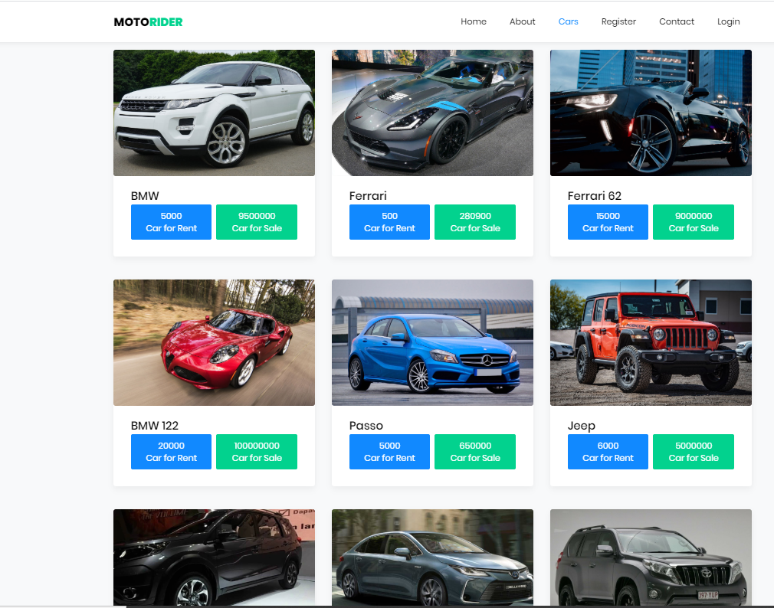

Code Snippet:-

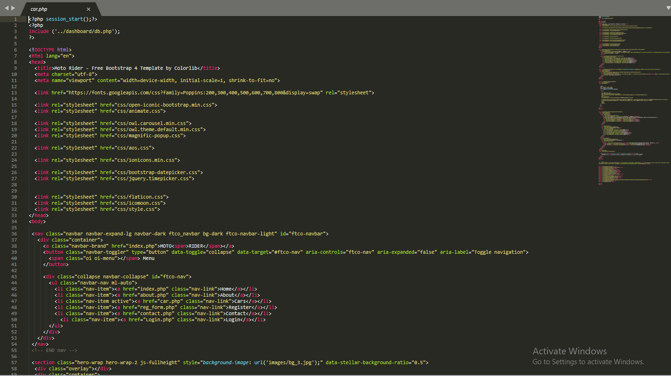



REGISTER: -

This is the page user can evaluate all the sales purchases profits losses etc.

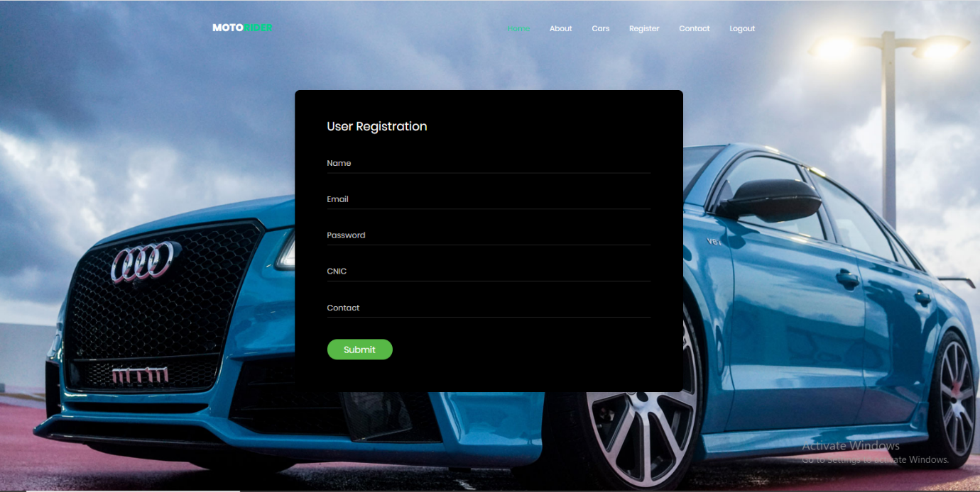

Code Snippet





CONTACT: -

If admin wants to add more users/cashier to the system this is the page to visit.

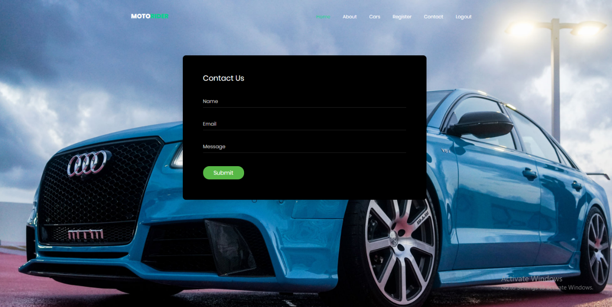

Code Snippet

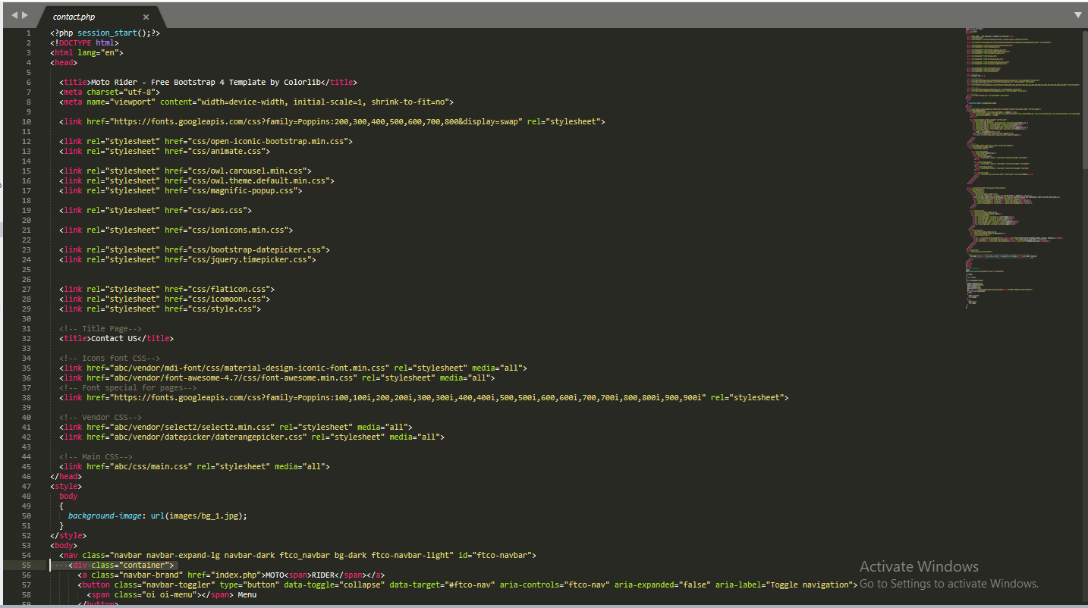



ADMIN: -

This is the last page of our application where admin can change his/her user name and password as well as if admin wishes to add another admin he can do so.

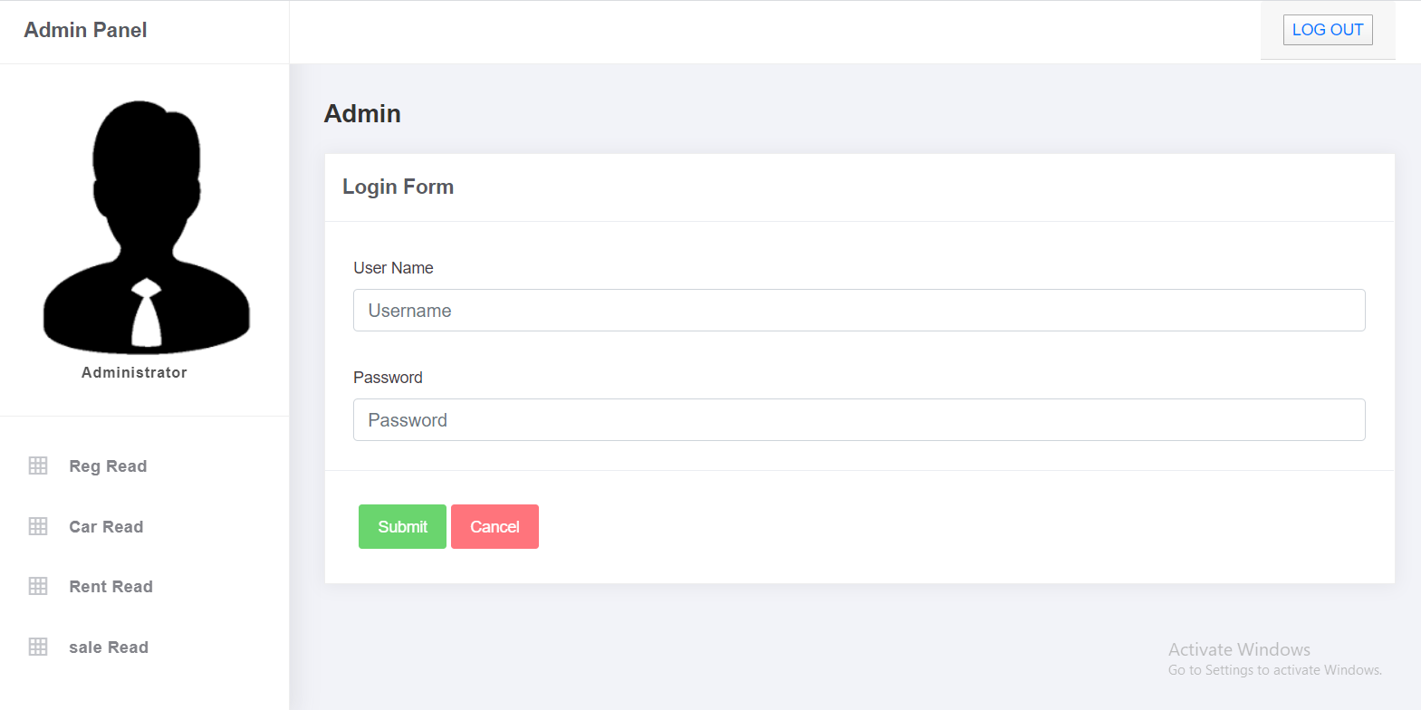

Code Snippet

